

**Winter – SEMESTER 2022 - 23 Name:** Nidhi Singh

**Course Code:** MCSE506P **Reg. No:**22MAI0015

**Course-Title:** – Database Systems Lab

**DIGITAL ASSIGNMENT - V**

**(LAB)**

**Slot-** L29+L30

**Faculty:** Dr. KARTHIK G M - SCOPE

**EXCEPTION HANDLING IN PL/SQL**

**8. DISPLAY THE NAME OF THAT MANAGER WHO HAS JOINED THE ORGANIZATION IN THE YEAR 1999. IF THERE IS NO OUTPUT OR IF THERE IS MORE THAN ONE OUTPUT THEN INSTEAD OF GIVING ERROR THE PROGRAM MUST GIVE PROPER MESSAGE.**

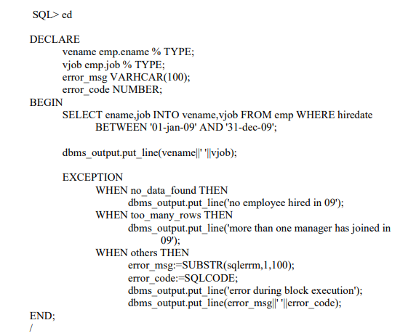

|  |
| --- |
| **SQL> ed**  **Wrote file afiedt.buf**  **1 DECLARE**  **2 vename emp.ename % TYPE;**  **3 vjob emp.job % TYPE;**  **4 error_msg VARCHAR(100);**  **5 error_code NUMBER;**  **6 BEGIN**  **7 SELECT ename,job INTO vename,vjob FROM emp WHERE hiredate**  **8 BETWEEN '08-sep-81' AND '23-jan-82';**  **9 dbms_output.put_line(vename||' '||vjob);**  **10 EXCEPTION**  **11 WHEN no_data_found THEN**  **12 dbms_output.put_line('no employee hired in 09');**  **13 WHEN too_many_rows THEN**  **14 dbms_output.put_line('more than one manager has joined in**  **15 09');**  **16 WHEN others THEN**  **17 error_msg:=SUBSTR(sqlerrm,1,100);**  **18 error_code:=SQLCODE;**  **19 dbms_output.put_line('error during block execution');**  **20 dbms_output.put_line(error_msg||' '||error_code);**  **21* END;**  **SQL> /**  **more than one manager has joined in**  **09**  **PL/SQL procedure successfully completed.** |

**SUBPROGRAMS IN PL/SQL USING PROCEDURES & FUNCTIONS**

**9A. CREATE A PROCEDURE INCR AND INCREASE THE SALARY OF EMPLOYEE.**

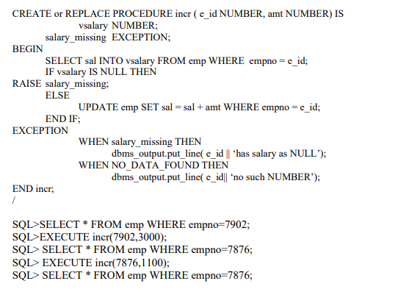

|  |
| --- |
| **SQL> ed**  **Wrote file afiedt.buf**  **1 CREATE or REPLACE PROCEDURE incr ( e_id NUMBER, amt NUMBER) IS**  **2 vsalary NUMBER;**  **3 salary_missing EXCEPTION;**  **4 BEGIN**  **5 SELECT sal INTO vsalary FROM emp WHERE empno = e_id;**  **6 IF vsalary IS NULL THEN**  **7 RAISE salary_missing;**  **8 ELSE**  **9 UPDATE emp SET sal = sal + amt WHERE empno = e_id;**  **10 END IF;**  **11 EXCEPTION**  **12 WHEN salary_missing THEN**  **13 dbms_output.put_line( e_id || 'has salary as NULL');**  **14 WHEN NO_DATA_FOUND THEN**  **15 dbms_output.put_line( e_id|| 'no such NUMBER');**  **16* END incr;**  **SQL> /**  **Procedure created.** |

**SQL>SELECT * FROM emp WHERE empno=7902;**

|  |
| --- |
| SQL> select * from emp where empno=7902;  EMPNO ENAME JOB MGR HIREDATE  ---------- -------------------- -------------------- ---------- ---------  SAL COMM DEPTNO  ---------- ---------- ----------  7902 ford analyst 7566 04-DEC-81  3000 20 |

**SQL>EXECUTE incr(7902,3000);**

|  |
| --- |
| SQL> execute incr(7902,3000);  PL/SQL procedure successfully completed. |

**SQL> SELECT * FROM emp WHERE empno=7876;**

|  |
| --- |
| SQL> select * from emp where empno=7876;  EMPNO ENAME JOB MGR HIREDATE  ---------- -------------------- -------------------- ---------- ---------  SAL COMM DEPTNO  ---------- ---------- ----------  7876 adams clerk 7788 12-JAN-83  1100 20 |

**SQL> EXECUTE incr(7876,1100);**

|  |
| --- |
| SQL> execute incr(7876,1100);  PL/SQL procedure successfully completed. |

**SQL> SELECT * FROM emp WHERE empno=7876;**

|  |
| --- |
| **SQL> select *from emp where empno=7876;**  EMPNO ENAME JOB MGR HIREDATE  ---------- -------------------- -------------------- ---------- ---------  SAL COMM DEPTNO  ---------- ---------- ----------  7876 adams clerk 7788 12-JAN-83  2200 20 |

**FUNCTION**

**9B. CREATE A FUNCTION TO CALCULATE THE NET SALARY BASED ON VARIOUS CONDITIONS. THE EMPLOYEE NUMBER IS PARAMETER. THE FUNCTION RETURNS THE VALUE OF THE INCREMENT.**

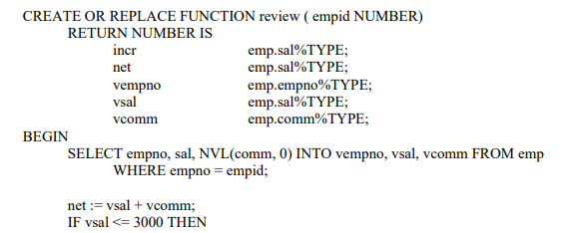

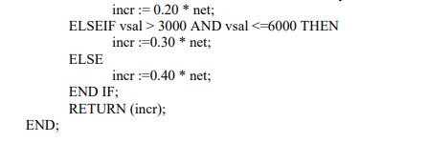

|  |
| --- |
| **SQL> ed**  **Wrote file afiedt.buf**  1 CREATE OR REPLACE FUNCTION review ( empid NUMBER)  2 RETURN NUMBER IS  3 incr emp.sal%TYPE;  4 net emp.sal%TYPE;  5 vempno emp.empno%TYPE;  6 vsal emp.sal%TYPE;  7 vcomm emp.comm%TYPE;  8 BEGIN  9 SELECT empno, sal, NVL(comm, 0) INTO vempno, vsal, vcomm FROM emp  10 WHERE empno = empid;  11 net := vsal + vcomm;  12 IF vsal <= 3000 THEN  13 incr := 0.20 * net;  14 ELSIF vsal > 3000 AND vsal <=6000 THEN  15 incr :=0.30 * net;  16 ELSE  17 incr :=0.40 * net;  18 END IF;  19 RETURN (incr);  20* END;  SQL> /  **Function created.** |

**PL/SQL BLOCK CALLING REVIEW FUNCTION:**

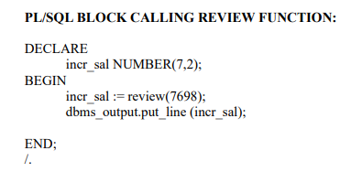

|  |
| --- |
| **SQL> ed**  **Wrote file afiedt.buf**  1 DECLARE  2 incr_sal NUMBER(7,2);  3 BEGIN  4 incr_sal := review(7698);  5 dbms_output.put_line (incr_sal);  6* END;  SQL> /  **576**  **PL/SQL procedure successfully completed.** |

**10A. CREATE A PACKAGE WITH FUNCTION TO INCREMENT THE SALARY AND RAISE ERROR MESSAGE IF ANY.**

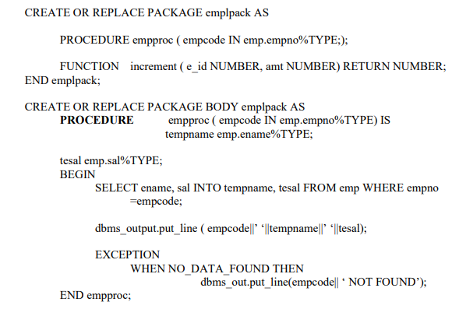

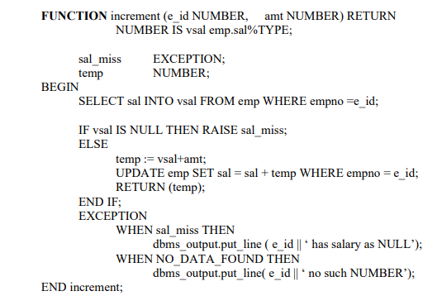

END emplpack;

|  |
| --- |
| **SQL> ed**  **Wrote file afiedt.buf**  1 CREATE OR REPLACE PACKAGE BODY emplpack AS  2 PROCEDURE empproc ( empcode IN emp.empno%TYPE) IS  3 tempname emp.ename%TYPE;  4 tesal emp.sal%TYPE;  5 BEGIN  6 SELECT ename, sal INTO tempname, tesal FROM emp WHERE empno=empcode;  7 dbms_output.put_line (empcode||''||tempname||''||tesal);  8 EXCEPTION  9 WHEN NO_DATA_FOUND THEN  10 dbms_output.put_line(empcode||'NOT FOUND');  11 END empproc;  12 FUNCTION increment (e_id NUMBER, amt NUMBER) RETURN  13 NUMBER IS vsal emp.sal%TYPE;  14 sal_miss EXCEPTION;  15 temp NUMBER;  16 BEGIN  17 SELECT sal INTO vsal FROM emp WHERE empno =e_id;  18 IF vsal IS NULL THEN RAISE sal_miss;  19 ELSE  20 temp := vsal+amt;  21 UPDATE emp SET sal = sal + temp WHERE empno = e_id;  22 RETURN (temp);  23 END IF;  24 EXCEPTION  25 WHEN sal_miss THEN  26 dbms_output.put_line ( e_id || ' has salary as NULL');  27 WHEN NO_DATA_FOUND THEN  28 dbms_output.put_line( e_id || ' no such NUMBER');  29 END increment;  30* END emplpack;  SQL> /  **Package body created.** |

**PL/SQL block with package:**

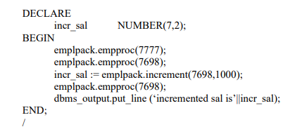

|  |
| --- |
| **SQL> ed**  **Wrote file afiedt.buf**  1 DECLARE  2 incr_sal NUMBER(7,2);  3 BEGIN  4 emplpack.empproc(7777);  5 emplpack.empproc(7698);  6 incr_sal := emplpack.increment(7698,1000);  7 emplpack.empproc(7698);  8 dbms_output.put_line ('incremented sal is'||incr_sal);  9* END;  SQL> /  **7777NOT FOUND**  **7698blake2850**  **7698blake6700**  **incremented sal is3850**  **PL/SQL procedure successfully completed.** |

**10B. WRITE A TRIGGER TOTAL SAL TO MAINTAIN A DERIVED COLUMN TOTSAL THAT STORES TOTAL SALARY OF ALL MEMBERS IN A DEPARTMENT.**

**Procedure to Execute Trigger:**

**1.Alter a table dept with an additional column totasal**

SQL>alter table dept add totsal VARHCAR(20);

|  |
| --- |
| **SQL> alter table dept add totsal varchar(20);**  Table altered. |

**2.UPDATE dept by totsal**

SQL>UPDATE dept totsal=(SELECT sum(sal) FROM emp WHERE emp.deptno=dept.deptno);

|  |
| --- |
| **SQL> update dept set totsal=(select sum(sal) from emp where emp.deptno=dept.deptno);**  4 rows updated. |

SQL>SELECT * FROM, dept;

|  |
| --- |
| **SQL> select * from dept;**  **DEPTNO DNAME LOC TOTSAL**  **---------- -------------------- -------------------- --------------------**  **10 accounting new york**  **20 research dallas**  **30 sales chicago 4100**  **40 operations boston** |

**3.Execute the program**

**SQL>/ Trigger CREATEd.**

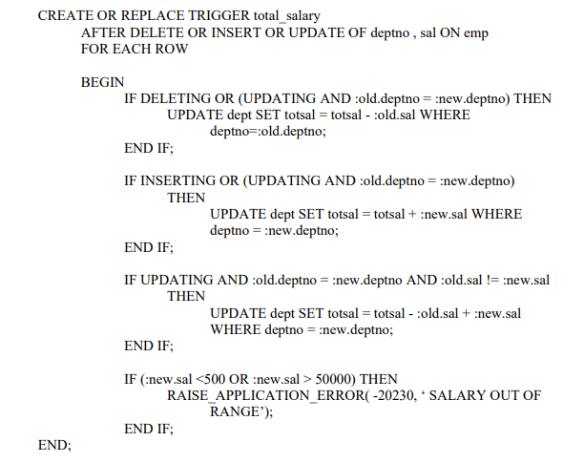

|  |
| --- |
| SQL> ed  Wrote file afiedt.buf  1 CREATE OR REPLACE TRIGGER total_salary  2 AFTER DELETE OR INSERT OR UPDATE OF deptno , sal ON emp  3 FOR EACH ROW  4 BEGIN  5 IF DELETING OR (UPDATING AND :old.deptno = :new.deptno) THEN  6 UPDATE dept SET totsal = totsal - :old.sal WHERE  7 deptno=:old.deptno;  8 END IF;  9 IF INSERTING OR (UPDATING AND :old.deptno = :new.deptno)  10 THEN  11 UPDATE dept SET totsal = totsal + :new.sal WHERE  12 deptno = :new.deptno;  13 END IF;  14 IF UPDATING AND :old.deptno = :new.deptno AND :old.sal != :new.sal  15 THEN  16 UPDATE dept SET totsal = totsal - :old.sal + :new.sal  17 WHERE deptno = :new.deptno;  18 END IF;  19 IF (:new.sal <500 OR :new.sal > 50000) THEN  20 RAISE_APPLICATION_ERROR( -20230, ' SALARY OUT OF RANGE');  21 END IF;  22* END;  SQL> /  **Trigger created.** |

**SQL> DELETE FROM emp WHERE empno=7900;**

|  |
| --- |
| **SQL> delete from emp where empno=7900;**  **1 row deleted.** |

**SQL> SELECT * FROM dept;**

|  |
| --- |
| **SQL> select * from dept;**  **DEPTNO DNAME LOC TOTSAL**  **---------- -------------------- -------------------- --------------------**  **10 accounting new york**  **20 research dallas**  **30 sales chicago 4100**  **40 operations boston** |

**SQL> INSERT INTO emp VALUES(8000,'Karthik','dbaprgm',7782,'12-aug-08',800,500,30);**

|  |
| --- |
| **SQL> insert into emp values(8000,'Karthik','dbaprgm',7782,'12-aug-08',800,500,30);**  **1 row created.** |

**SQL> SELECT * FROM dept;**

|  |
| --- |
| **SQL> select * from dept;**  **DEPTNO DNAME LOC TOTSAL**  **---------- -------------------- -------------------- --------------------**  **10 accounting new york**  **20 research dallas**  **30 sales chicago 4900**  **40 operations boston** |

**SQL> INSERT INTO emp VALUES(8000,'Karthik','dbaprgm',7782,'12-aug08',8000,500,30);**

**INSERT INTO emp VALUES(8000,'Karthik','dbaprgm',7782,'12-aug-08',8000,500,30) \***

|  |
| --- |
| **SQL> insert into emp values(8000,'Karthik','dbaprgm',7782,'12-aug-08',8000,500,30);**  **1 row created.** |

**SQL> UPDATE emp SET sal=800 WHERE empno=7876;**

|  |
| --- |
| **SQL> update emp set sal=800 where empno=7876;**  **1 row updated.** |

**SQL> SELECT * FROM dept;**

|  |
| --- |
| **SQL> select * from dept;**  DEPTNO DNAME LOC TOTSAL  ---------- -------------------- -------------------- --------------------  10 accounting new york  20 research dallas  30 sales chicago 12900  40 operations boston |